Muskingum Student Self-Service - Academics

Created: July 16, 2024, by Registrar’s Office
Updated: July 16, 2024, by Registrar’s Office
Purpose: Empower students and provide a better experience

General Navigation
The vast majority of the information students will need for academic purposes will reside within ‘Student Planning.’
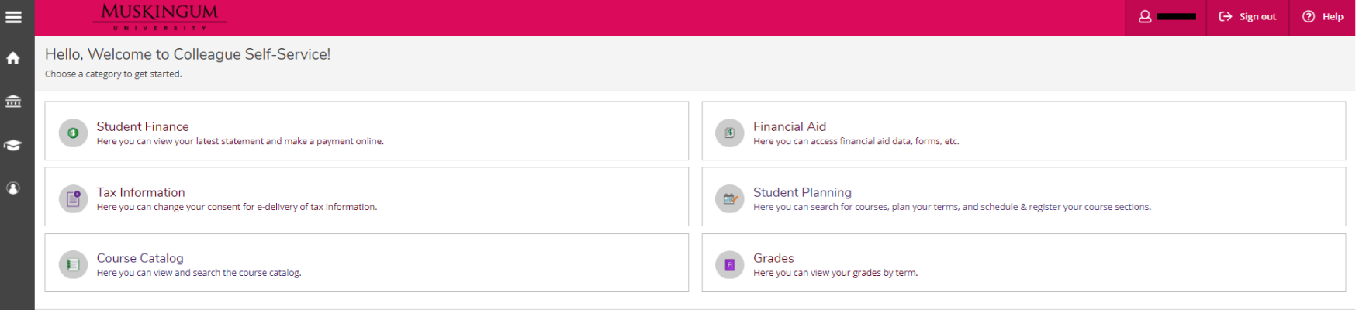
In additions to the buttons, students can click on the left-hand side to expand academics, which is where the links for official transcripts and enrollment verifications requests reside.
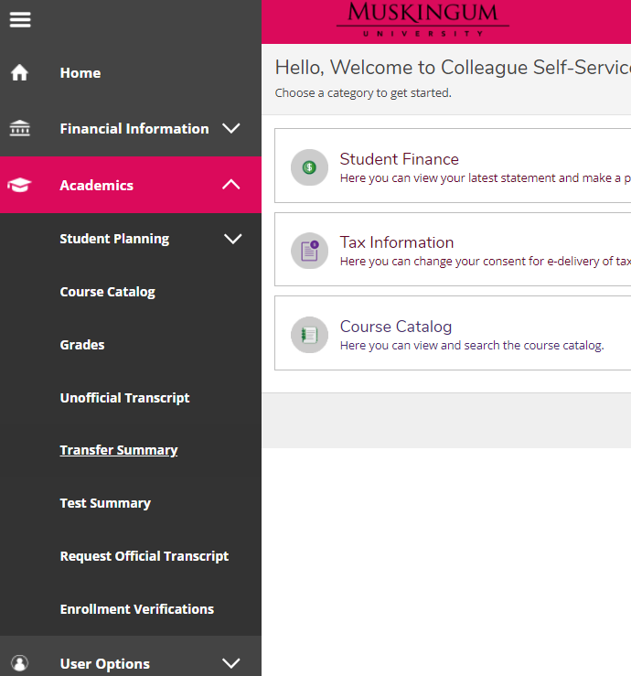

Course Catalog
The course catalog, which is an independent button within Self-Service, is directly connected to Student Planning, because you add courses and/or sections from the catalog to the student’s plan, and the plan is used to register. You can go directly to the Course Catalog and search OR you can go to search from within the student’s plan.

**Adding a course to a student’s plan is NOT the same as adding a section. You must give students the ability to plan their educational pathway in advance of having your detailed schedule(s) available, so students/advisors can plan a course (with no section information associated with it). Students/advisors must then add a section of the course to the student’s schedule to be able to register**

You can either use Advanced Search or Search by courses options on this screen.
Advanced Search Section Listing: View sections filtered by term subject, location, time, etc.
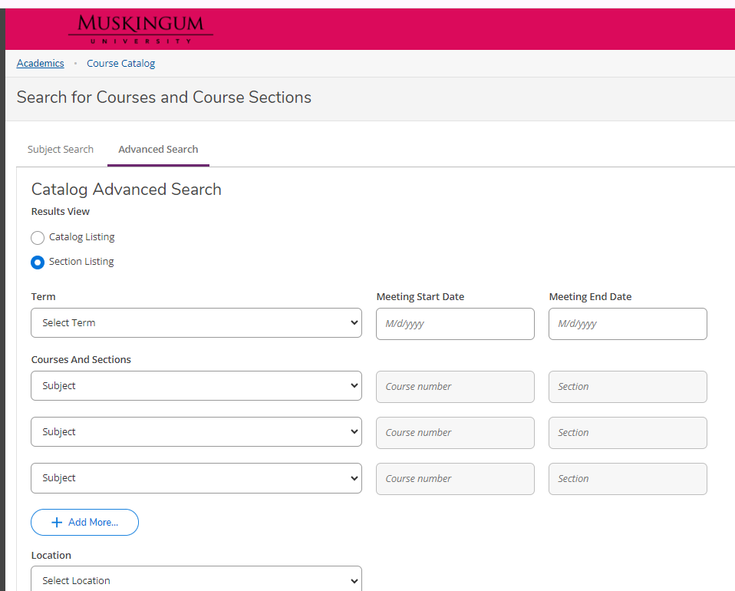
Example, use Advanced Search to find all the courses that are offered in the 2024 fall that are for traditional undergraduate students.

- On the advanced search tab, click on Term drop down and select 2024 Fall Semester

- Scroll down to Course Type and choose “Traditional UG”. Please note that you can only search based on one course type.

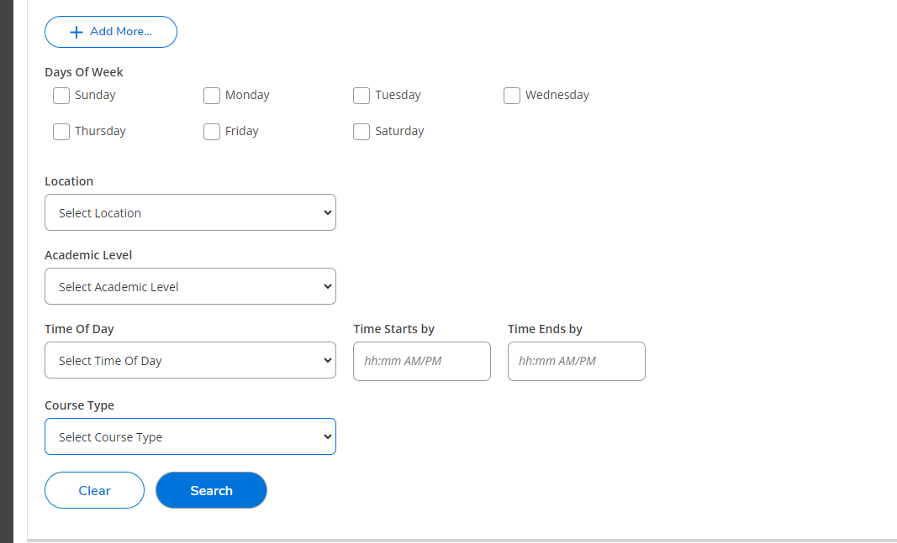
- Scroll all the way to the bottom and click on the Search button in blue.



Results:

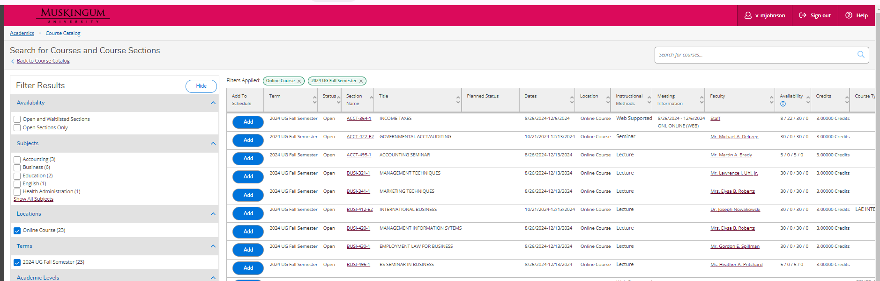

You will see a detailed description of the course section you selected including Instructor’s name, Location of class, dates, credits and requisites. Click on Add to finalize your selection.
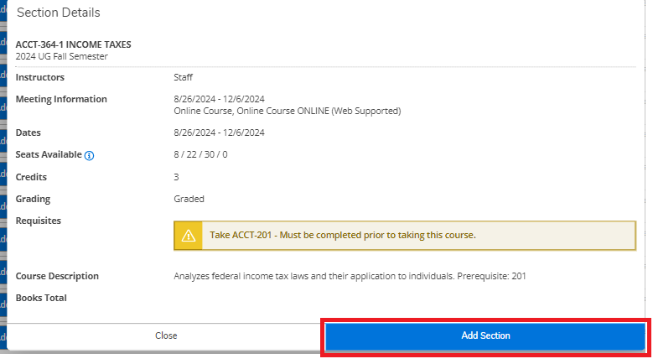
You will get a green colored notification on the top-right corner of your Self-Service that the course has been added to your plan.


If you have already completed/attempted a course, you will see a blue banner under the course description as in the screenshot below:
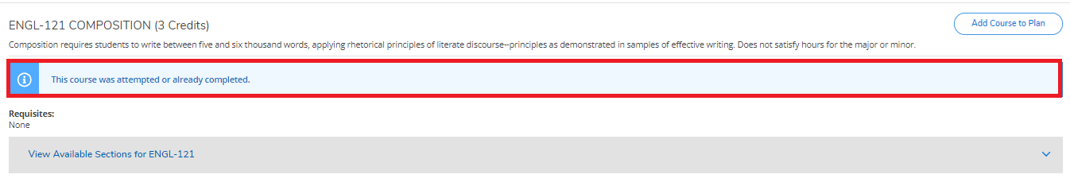

When a course has been added to your plan, you will see a Yellow banner like this under the course name:
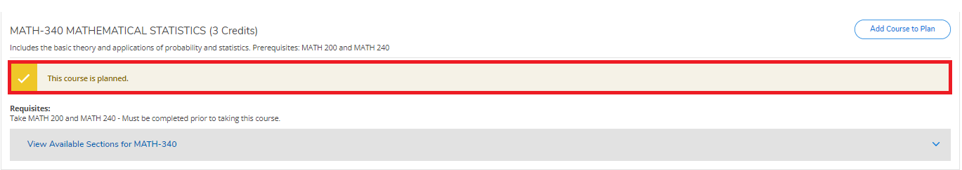
WARNING: Adding the courses to a student’s Course Plan DOES NOT mean they have been registered. Now, you must navigate back home by clicking on the home icon. Then move to the next step.

Student Planning, Advising, & Graduation

Schedule
- Click on the Student Planning button.
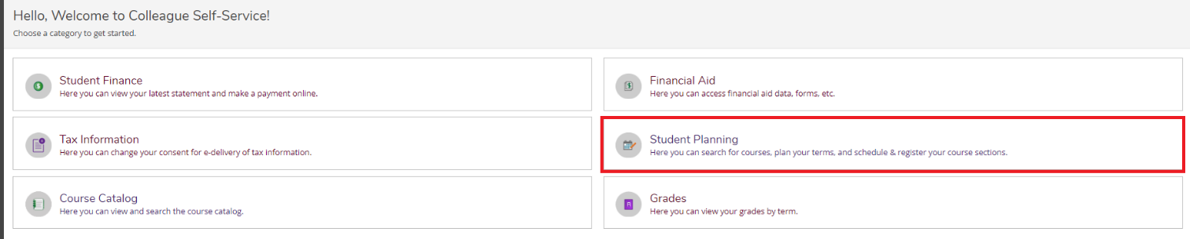
- Click on ‘Go to Plan & Schedule’
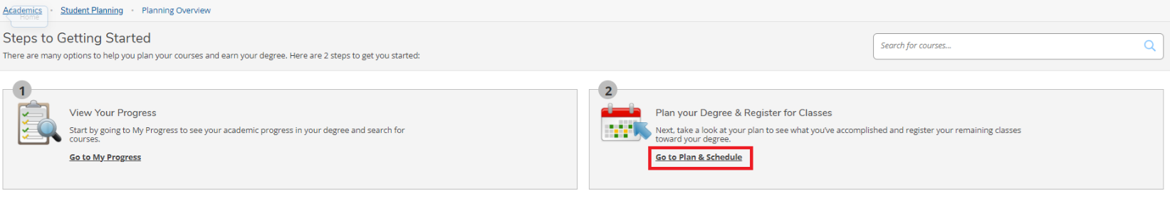
A student’s schedule is a more comprehensive view of the student’s plan by term and is the place from which a student can register. Student planning and registration go together in terms of Self-Service. A student can only register for a section that resides on their plan. Arrow buttons can be used to toggle between the terms, which can include their plan and/or registration. The ‘+’ sign is used to add additional terms to the student’s plans. The terms available within the ‘+’ sign are driven by back-end settings controlled by the Registrar’s Office. The register/drop buttons will only appear/be clickable if the student is eligible to register.
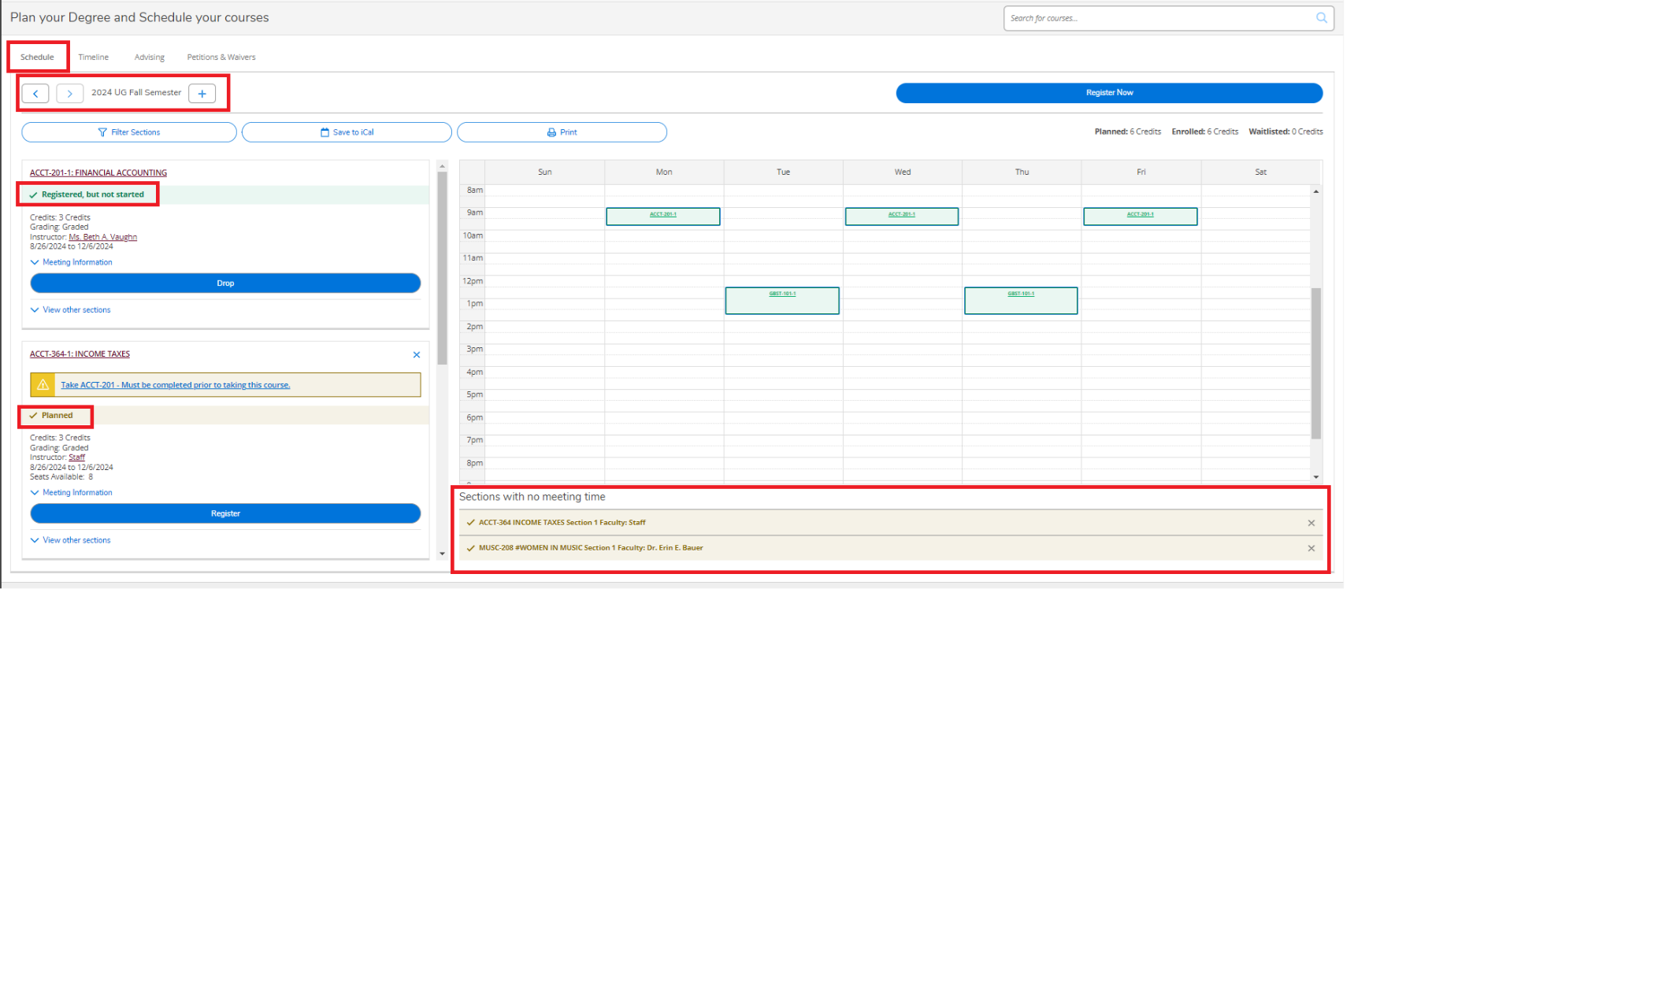

Schedule - Calendar View
**The examples below are not Muskingum courses**
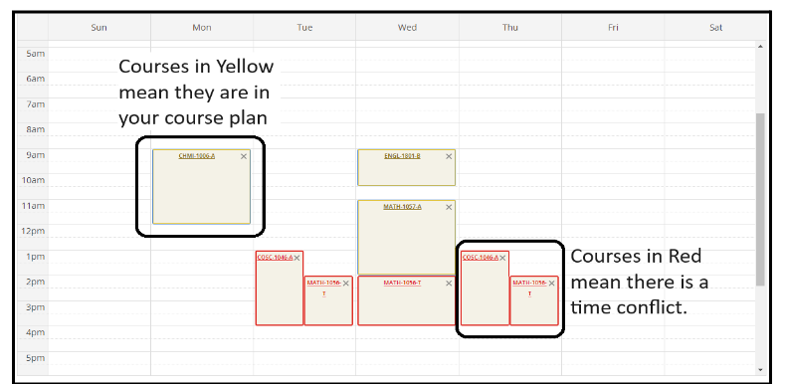
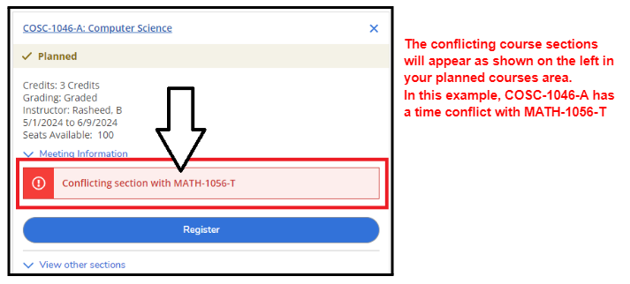
To fix this time conflict, scroll to the conflicting course and then click on View other sections under it to view alternative sections being offered for your selected course.
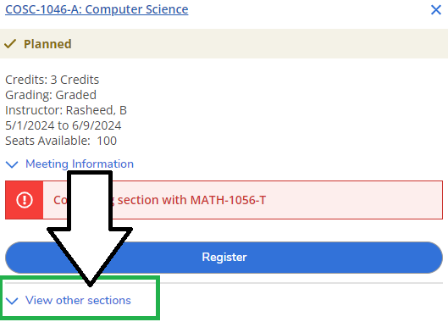

Once you click on it, the calendar will display other sections available for the conflicting course.
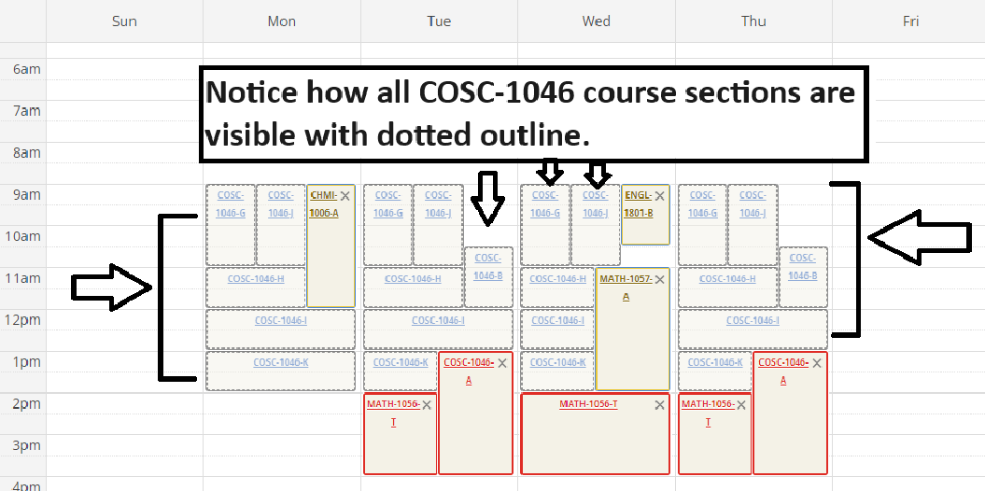
Click on the desired section by either by clicking on the section title on Calendar OR from the section drop-down to the left of the calendar.
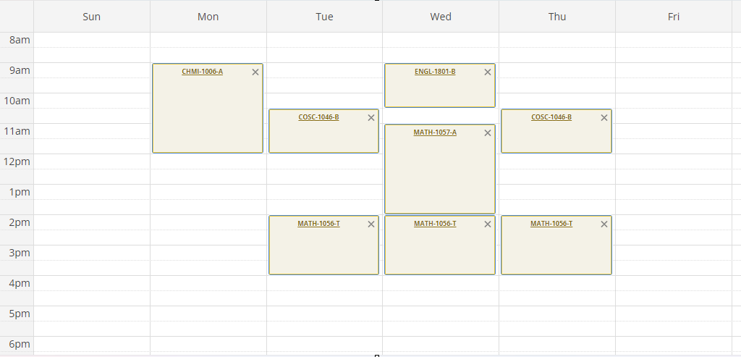

Click on the register now button to register the student in all the courses that they have on your student plan.
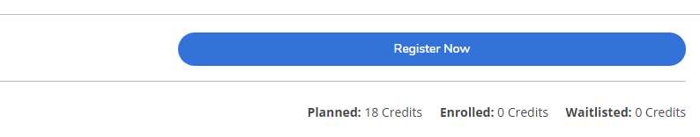

Alternatively, you can click on the register button under each course to register the student for courses individually.
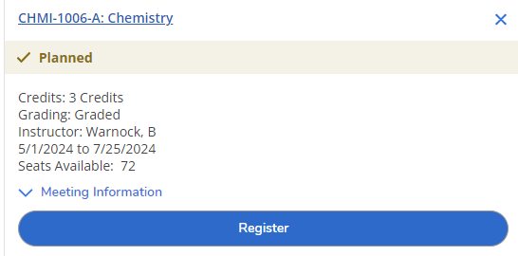

Once the student has been registered, the courses on their calendar will change to green.
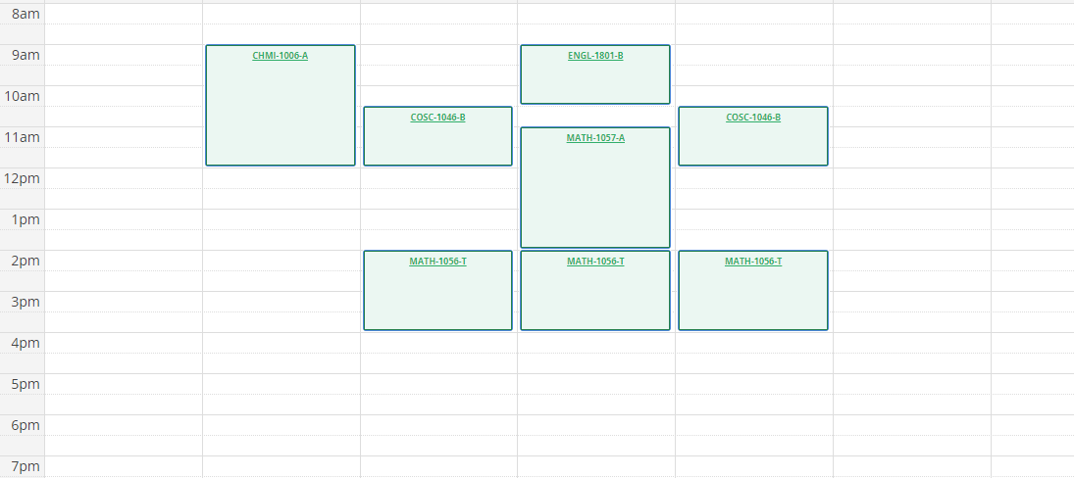

Search for and Add Courses/Sections from within the MyProgress (specific to the requirement)
When you are in Progress for a student and click the Search button for any given requirement, the system will automatically take you to the Course Catalog and pre-filter the results based on the requirement for which you clicked the search button.
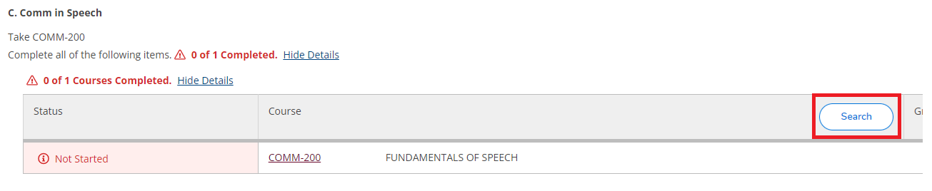

You can either add the course to the student’s plan OR add a section to the student’s schedule. Note that the course being on the plan does not allow for registration. A specific section of the course must be on the student’s schedule to enable registration.
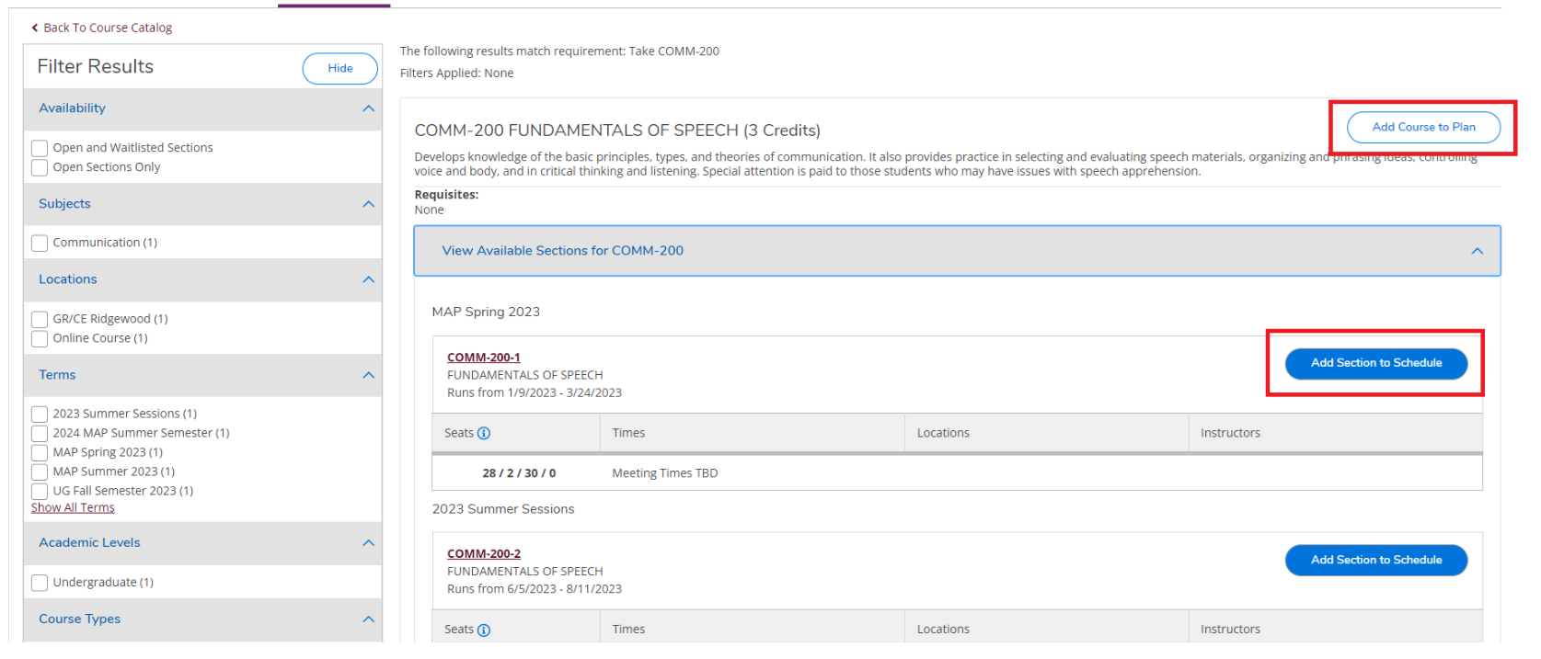

Unofficial Transcript
Click on the Unofficial Transcript link from the left-hand navigation menu and click on the link of the respective unofficial transcript you wish to view.
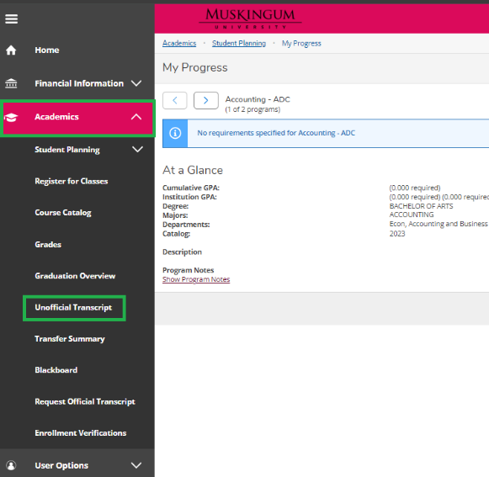
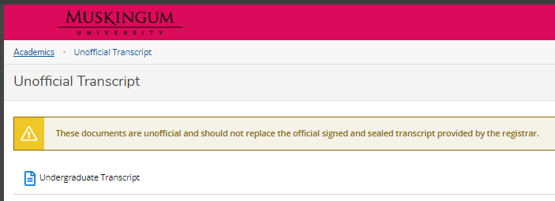

Transfer Summary
Transfer summary provides an overview of transfer courses/credit a student has received. Click on the Transfer Summary link from the left-hand navigation menu and expand external institutions on your record to view transfer credit.
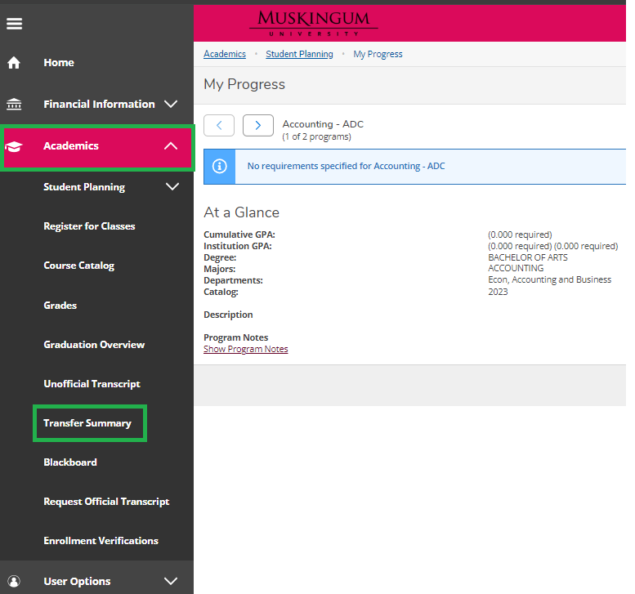
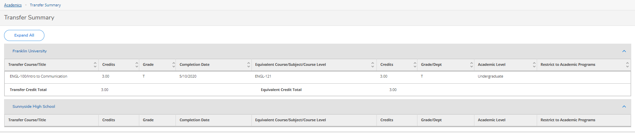

Grades
Click on the ‘Grades’ button and expand the term(s) for which you wish to view your grades.
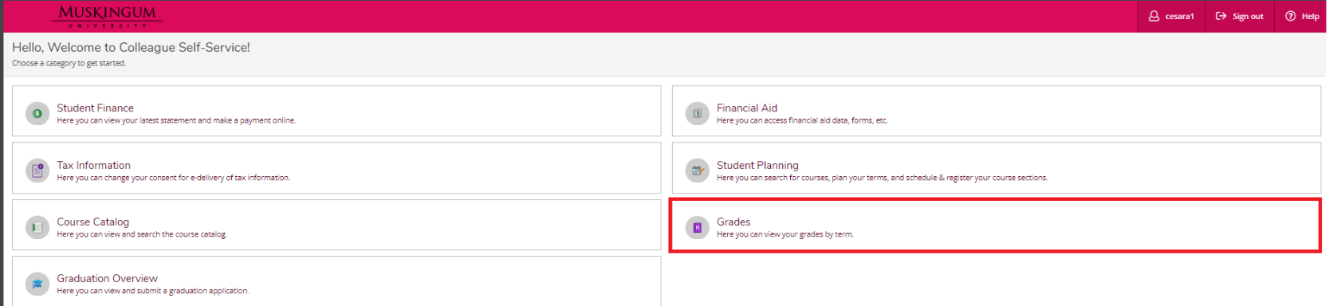
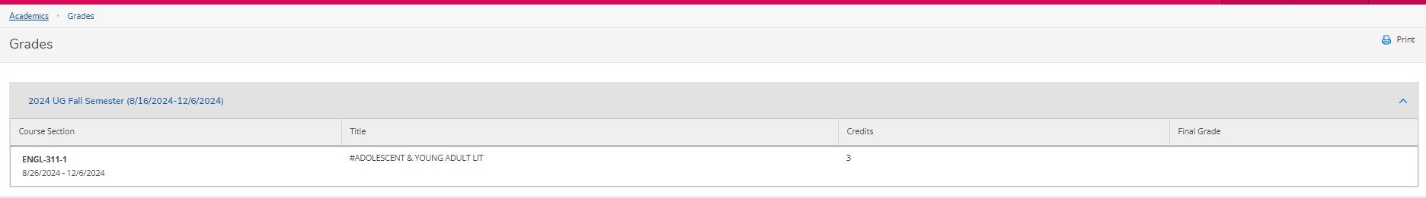

Graduation Application
Click on the Graduation Overview button from the landing page or link from the left-hand navigation menu.
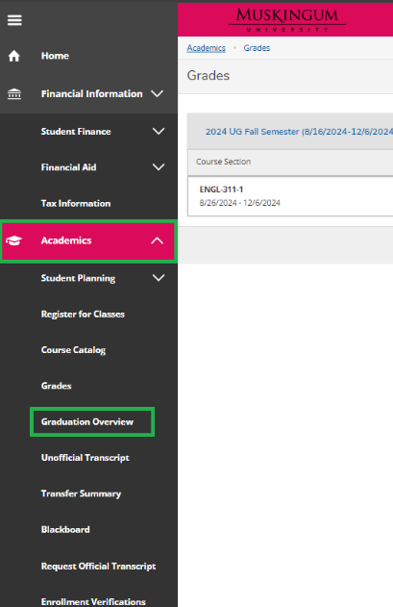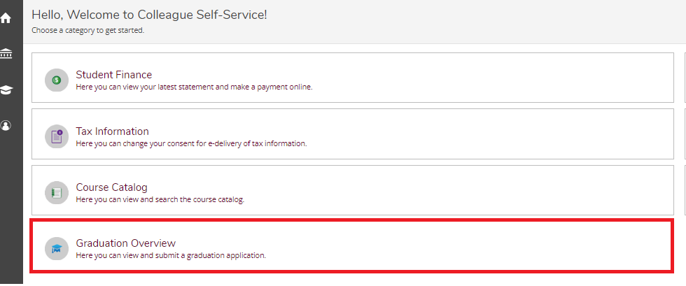
Students must be actively enrolled in a program to be able to apply to graduate from it. The fields and ability to edit are controlled by settings by the Registrar’s Office.
