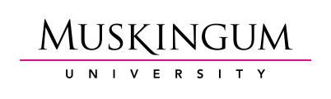

STAFF PERFORMANCE REVIEW

Staff Member:
Position and Department:
Supervisor:
Period Covered By This Review:

Muskingum University encourages regular communication between staff and their immediate supervisors on goals, accomplishments, and areas for greater focus or improvement. This form is meant as a foundation for an annual discussion of performance.

Areas for Discussion (to be completed by the supervisor)
♦ Job Knowledge
(Knowledge of the professional field and of Muskingum University policies and procedures)

♦ Quality of Work
(Consider characteristics such as the ability to set priorities, to be timely, accurate and consistent)

♦ Communication
(Effectively communicates with others in writing and speaking, listens carefully, represents the University well in internal and external communications)

♦ Innovation
(Willingness to try new and different approaches to reach department goals, uses creativity, imagination and information to develop ideas)

♦ Working Relationships/Teamwork
(Maintains strong working relationships inside and outside the department, is considered a strong member of cross-functional teams, respects and assists co-workers in achieving their goals)

♦ Supervision – For Those Who Supervise Others
(Does the administrator effectively manage the department, demonstrate leadership, and provide opportunity for development for department members?)

♦ Summary of Overall Performance

♦ Professional Development
(Describe any specific action you would recommend to enhance the employee’s professional and personal qualifications as related to future professional developments)

♦ Performance Goals
(Indicate performance areas where improvement may be warranted and outline action plans to assist the employee in achieving a higher level of performance. Include specific actions and target dates)

______________________________ _______________________
Reviewer’s Signature Date
The signature indicates that the staff member has read and had an opportunity to discuss the review with the reviewer.

______________________________ _______________________
Staff Signature Date

