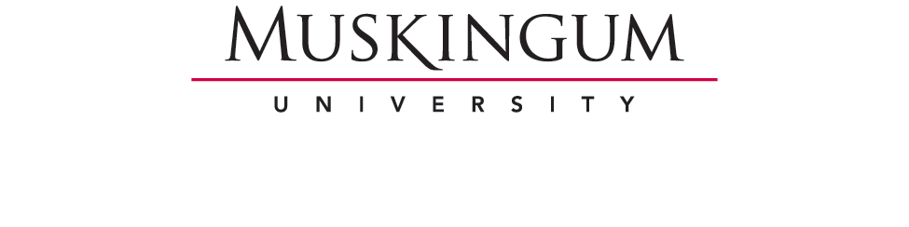

Student Financial Services
260 Stadium Drive
New Concord, OH 43762

STATEMENT OF EDUCATIONAL PURPOSE

I certify that I, ___________________________________ am the individual signing this
Student’s Printed Name

Statement of Educational Purpose and that the federal student financial assistance I may receive

will only be used for educational purposes and to pay the cost of attending Muskingum

University for 2025-2026.

Student’s Signature______________________________________ Date _________________

Student’s I.D. Number _________________
If you are unable to appear in person in the Financial Aid office, you may sign this in the presence of a Notary Public and have them acknowledge your signed statement and a copy of your I.D.

STATE OF _________________ COUNTY OF _____________
State County
On _____________, before me, __________________________________ ,
Date Notary’s Name
personally appeared, ______________________________________, and proved to me on basis
Printed Name of Signer
of satisfactory evidence of identification ________________________________________
Type of government-issued photo ID provided
to be the above named person who signed the foregoing instrument.
Witness my hand and official seal before me this ____ day of ___________ 20___.
_____________________________
Notary Public Signature
STAMP
_____________________________
My Commission Expires

