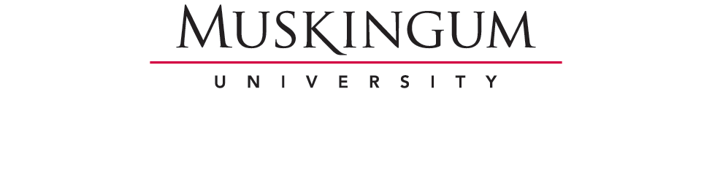

2016-2017 UNDERGRADUATE MAJORS
PROGRAM ASSESSMENT REPORT
Due Date: July 1, 2017 with copy to Division Coordinator.

Department/Program:
Submitted By:

Program Mission Statement:

Program Vision Statement:

Learning Assessment Progress Report
[To be completed by the department chair or committee using the department’s current academic year data]

Program Learning Goals Continuation [ ] Changed/New to this Report [ ]

Assessment Methods Used

Student Learning Assessment Data Report for the Current Year

Analysis of Current-Year Learning Assessment Data
Strengths

Weaknesses

Overall Analysis/Commentary

Issue/Item Revealed Through Assessment That – If Addressed – Would Improve Student Learning

Action Plan to Address Issue Identified Above

Comparison of Current Year Assessment Data with Data from Previous Two Years
Noteworthy Overall Patterns/Trends

Newly-Emerging Patterns or Trends

Persistent Patterns or Trends Not Noted Above

Overall Analysis

Action Plan

Describe all changes to assessment methods and/or strategies resulting from the analysis of the assessment data

Describe all changes made in the program’s curriculum, course content, or teaching methods resulting from assessment data analysis.

Teaching Profile [Data supplied by Academic Affairs]

Comparative course evaluations data for department and division. Data from Academic Affairs. Department chair will reflect on quality of teaching in relation to course evaluation data.

Program Initiatives in Support of Student Learning
Newly-Undertaken This Reporting Year:

Ongoing:

Eliminated/Suspended, plus Rationale:

Technology or equipment (etc.) added, upgraded or notably used this year in support of instruction and learning.

Teaching Awards/Honors to Program Faculty This Year

Student Professional Development Initiatives

Describe efforts designed by the department to assist students with career-planning and readiness, and/or graduate study. In particular, kindly note efforts in areas that research shows is especially valued by employers when considering recent college graduates.

Career
Internship initiatives (Internal and External):

Projects that engage students in “Real World” applications of skills or knowledge acquired in the classroom:

Courses with significant amounts of writing, and the anticipated outcomes of such writing:

Collaborative research projects completed by students with peers and/or faculty:

Other activities designed by the department to engage students about – or enhance - career readiness:

In what other ways does the department: 1) Encourage students to reflect upon their learning, and; 2) Assist students to articulate the value of their major and the skills that they are developing?

Graduate Study

On-Campus/Community Programming and/or Outreach

Describe initiatives undertaken by the department/program.

Commentary regarding effect/results.

Discuss Plans/Ideas for Future Programming.

Budget Profile

- Discuss, generally, how funds allocated by the university have been used to enhance the attainment of student learning outcomes, expand learning opportunities for students, and to aid in professional development of faculty.
- Provide three specific/significant examples and their results.

Academic capital expenditures (Where Applicable)

Brief Commentary Regarding Management and Effectiveness of Operating Budget

Three Program Goals for the Next Academic Year
1)

2)

3)

Your program’s mission statement should distinguish your program from other programs or units. Consider: If the name of your program were to be removed from your statement, would that statement still apply uniquely to your unit? Guidance in formulating a mission statement may be obtained from the Academic Affairs “Program Assessment” webpage.
Goals/Outcomes are to be framed in the “students will be able to…” (or similar) format. The key word here is “will,” followed by a concrete and measurable active descriptor. “Students will be able to recognize the name of Alexander the Great’s horse,” for example. Assistance in coming up with words to use in these types of phrases may be obtained from the “Assessment Resources For Faculty” page of the Academic Affairs website (See: “Benjamin Bloom's Taxonomy of Measurables and Words to Avoid”) For “complex learning” outcomes often associated with the liberal arts (Sometimes also referred to as “values”), see: www.aacu.org/leap/vision.cfm with further links.
If changed or new, discuss how assessment motivated the change(s).
Assessments should include direct and indirect measures.
General comment/advice: As you look at your assessment data, consider its genuine utility. Is it what you need? Avoid collecting data that you cannot – or do not – use. More importantly, do not collect data that you cannot reasonably act upon. Experts in assessment note that it is far better to collect a small amount of useful data, than a mass of less-than-useful data. Since the goal of assessment is to take action through information-based decision making, focus your efforts on the collection of information you need so as to take wise – and feasible – action.
Include the holding of offices within professional organizations.

